ANNUAL REPORT 2019
FRIENDS OF ECOLE AGAPE, INC.
2019 proved to be a banner year for the Friends of Ecole Agape, with support from 116 sponsors and 109 donors. In our first year with four events: Chili Cook Off, Wine Tasting, Comedy Night and Pig Roast, we attracted a record number of over a thousand participants. Friends of Ecole Agape became a large, stronger and more versatile group with Stella Agront, Sissy Bernache, Lorraine Cloutier, and Marie Smith adding their individual talents.
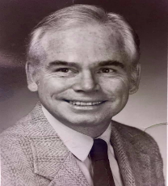
REMEMBERING. On July 10, 2019, we lost our beloved Michael McHugh. Michael was a founding member of the Haiti Ministry at St. Thomas Aquinas. He served as secretary, and supported sponsorship appeals and fundraisers. He was a part of every Haiti Awareness Program. Michael and his wife Pat designed the Banque Agape, a box in which parishioners could drop spare change after Mass. This brought in several thousand dollars each year. After the St Thomas Aquinas ministry dissolved in 2015, Michael continued his support of Haiti as a founding member of Friends of Ecole Agape. Inc. Michael and Pat maintained their yearly sponsorships, purchased computers, solar lights and filled many personal canisters with their spare change.
On September 20, 2019, Mary Wehrle a founding member of the Haitian Ministry at St. Thomas Aquinas and founding member of Friends of Ecole Agape, lost her beloved husband Edmund Wehrle. Mary and Edmund were financial contributors to the publication of an Anthology of Haitian Culture. They maintained multiple sponsorships each year as well as other donations. They traveled to Ecole Agape in Lilavois, Haiti as well as hosted Myrtha Manigat, the founder of Ecole Agape multiple times in their Storrs home. Friends and family remembered these benevolent and generous men with donations to Ecole Agape.
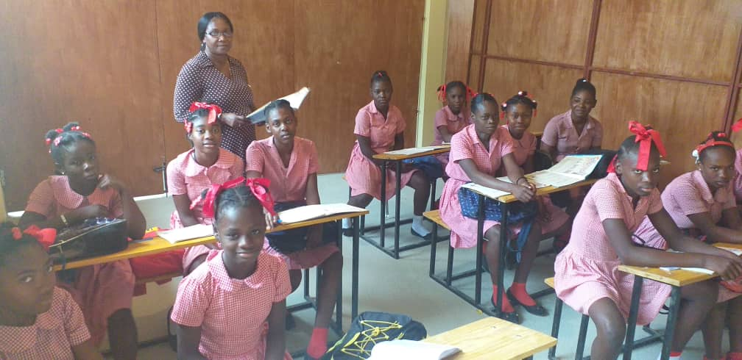
ECOLE AGAPE THE STUDENTS. The 2018 – 2019 Haitian School Year was officially 189 days, from September 9 to July 1. Two hundred thirty-four students, preschool through grade 6, began the school year, but were unable to complete their studies due to political unrest. Protestors threw rocks at students in schools that opened their doors. Parents came for their children amid burning tires, burning cars, rock throwing and gunshots between police and protestors. Students were only able to attend school for 6 days in September, 0 days in October, 0 days in November, and 30 days in December. Despite the ongoing violence the school reported limited success with the curriculum. The students learned about safety, colors, benefits of fruits, vegetables, liquids. While the preschool students did rhyme games, the upper grades had a lecture contest. We gave tuition scholarships for 5 graduates to go on to 8th grade. One moved back to her hometown, but four students passed exams to begin the 9th grade next fall and wrote thank you letters to us.
ECOLE AGAPE STAFF. Due to the political unrest and the closing of the school in March, the teachers, librarian, and food service workers were unable to be regularly at the school, however salaries were paid through the year. Three teacher training sessions took place, one of which was “How to teach more effectively”, and one parent meeting was held. When school was in session, once a month recreational videos were shown students with a Miroir smalt tilt projector and computers provided by Friends of Ecole Agape.
ECOLE AGAPE THE PHYISCAL PLANT. On August 2, school construction started. We partnered with Haitian Turbo System SA, an information system engineering company established by CEO Carl Darbouze (Marie Michele’s husband) and three partners to provide funds for a new classroom building and the repair of Myrtha Manigat’s house. At completion, the bottom floor of the house contains 3 preschool classrooms, 1st grade classroom, 2nd grade classroom, a computer lab, a director’s office, a small working kitchen, and a bathroom for the teachers. The library was renovated inside and out with new windows to better protect the books. The new building contains 4 classrooms for grades 3-6, with moveable walls for assemblies, holiday celebrations, and religious services. Students in grades 1-6 will now be able to be in classes from 1 – 5 pm, since they no longer use borrowed space at the La Providence school. Friends of Ecole Agape members financed several additional independent projects: a sanitary block with 4 toilets, 2 sinks, a shower with tub; a water tower and pump, and a septic tank/system. The entrance was rehabilitated with a new gate and grading at the front of Myrtha’s house to prevent flooding and accommodate delivery trucks. A new free-standing kitchen was constructed which provided for additional food storage. Classroom benches, desks, and storage were designed and built by Haitian craftsmen. New Blackboards were placed in the classrooms.
JANUARY. On January 19, 2019 we held our First Annual Chili Cook Off. Participants sampled the chilis of 26 chefs while listening to the music of the Donalee and Laura B, Country Fiddlers, and Curtis Brand and the On Call Band. Winning chefs included: First Place, Ken’s Famous by Ken Tierney; Second Place, Angels Delight by John and Kacee Erhard; Third Place, Smokin’ Hot Texas Chili by David Rhodes. The Most Original Chili went to Rob Tierney with Not Your Ordinary Chili; the Most Smokin’ Hot Chili went to Cindy Moeckel and Larry Grasso with Mother of God This is Spicy; Best Presentation of a chili went to Susan Hacking and Michael Bartron. The response from the many newcomers was “this was a tremendously fun event for families. We will be back.”
FEBRUARY. We began to collect information on a variety of strategies for a successful Capital Campaign to repair Myrtha Manigat’s home and build additional classrooms.
MARCH. On March 23, 2019, Atelier Jean Charles Philippe sent preliminary architectural plans and cost estimates for a two -story, six classroom building. We made the decision to have our first Annual Sponsorship Appeal with the intent of increasing our sponsorship base.
APRIL. The 3rd Annual Wine Tasting on April 6 was a popular social event with many familiar faces returning for the evening. A variety of wines from Ashford Spirit Shoppe were paired with assorted appetizers, entrees, and desserts. Musical talent was provided by Thelma & Louise, Moxie, Morphus and Freedom from Tyranny. Amy Moore prepared hors d’oeuvres as well as organized and coordinated food donated by local businesses: American Eagle Saloon, 99 Restaurant & Pub, Dog Lane Café, Fenton River Grille, Gansett Wraps, Kathmandu Kitchen, Little Aladdin, Subway, Red Rock Café, Tokyo Ramen, and Starbucks. Anna Knutel provided floral arrangements and David Palmer donated his services of chair massage. Local Haitian art, paintings and crafts made for a successful Haitian Art Sale. The silent auction and raffle were a great success due to the generous donations from local businesses.
MAY. On May 10 we sent a barrel filled with paper, writing implements, math teaching aides, and clothing to Ecole Agape. Membership discussed the need for more information about the architectural plans submitted by Atelier Jean Charles Philippe before we began the Capital Campaign.
JUNE. On Friday, June 28, The Second Annual Comedy Night was held at St. Philip Parish Center. Rebecca Anne Lo Cicero, Master of Ceremonies Introduced comedians Rhonda Corey and Howie Mason. Music was by Seldom Heard. Donations by individual and businesses made for a successful silent auction.
JULY. On July 12, 2019, Lesly Guillite and Angie Mariah Lominy submitted an alternative construction proposal that repaired and reconfigured the Manigat House with more classroom space and proposed a single-story building. The interior did not have fixed walls but mobile partitions which could create 4 classrooms, or be removed to convert the building into a 96 square meter auditorium.
AUGUST. On August 2 the construction began on the new building creating 4 classroom and repair of Myrtha Manigat’s house. An average of 10 Haitian workers per day worked despite the difficult political turmoil, which included being shot at. Friends of Ecole Agape fed the workers daily. Marie Michelle reported that Turbo Systems, a Haitian Company committed funds to build a basic one-story structure and some repairs to Myrtha’s house. At our August meeting, Friends of Ecole Agape voted to use current funds to furnish the new building with benches, student and teachers’ desks, black boards, and necessary equipment for a computer lab.
SEPTEMBER. On September 13, 2019, five barrels of school supplies and instructional materials purchased by Friends of Ecole Agape were sent to Haiti. Additionally, Cathy Belanger donated a sewing machine. Marianne Labergerie donated an exceptional collection of French books, VCR tapes and CDs.
On September 14, 2019, despite the downpours of rain that punctuated the beginning and ending of the Fourth Annual Pig Roast, spirits were not dampened. Over 200 guests braved the weather and welcomed Chantal Coutard, our Educational Coordinator and guest Sister Susan Nchubiri. For the fourth year, Kevin White coordinated the musical talent and Nathaniel Picard-Busky was the audio engineer. Musical talent included: Curt Brand and the On Call Band (Jon Hand, Mark Campbell); the Faithful Sky Band (Hugh Blumenfeld, Jim Mercik, Jeff Buchbinder), Karen Lussier Band (Karen Lussier, Greg Arpin, Barbie Schreier, John Butler, Joe Rice, Bobby Tisher); Seldom Heard (Lee Terry, Tom Terry, Howard Drescher, Rhonda Kincaid); Who We Are (Kevin White, Frank Busse, John Jeff, William Quinn). Amy Moore organized and coordinated the food tent and the foods donated by local businesses: American Eagle Saloon, Big Y Mansfield, Dog Lane Café, Domino’s Pizza, Dunkin Donuts, EatJoy, Gansett Wraps, Hop Knot, Fenton River Grill, Kathmandu Kitchen and Bar, Natures Health Store, Price Chopper, Red Rock Café, Restaurant 99, Shaws, Spring Hill Cafe, Starbucks, and Willington Pizza. Pitmasters were John Erhard and Jeff Roets. Financial Patrons were Lorraine Cloutier, Amy Moore, Ed and Susan Passmore, American Heritage Roofing and Mansfield Supply.
On the 15 September 2019, Chantal Coutard and Sister Susan Nchubiri met with FEA members to discuss the progress on reconstruction of Myrtha Manigat’s house, construction of the new school, needs for new classrooms, plans for the new school, and plans for the future. On September 21, 2019 Jeannette Picard and Judy Melichar staffed the Ecole Agape Booth at the Celebrate Mansfield Festival.
OCTOBER. Members voted to appropriate immediate money for the sanitary block, repair of front entrance, pump system, indoor plumbing installation, exterior kitchen, benches, desks, blackboards, and storage units.
NOVEMBER. On November 13, we sent Ecole Agape $28,265 for construction costs. Our First Annual Sponsorship Appeal brought in 82 new sponsors to join our 34 previous sponsors. We realized over $20,000 in funds, helping greatly to maintain support of our students and school. Officers were reelected during our annual meeting.
DECEMBER. On December 16, 2019, we received first printing of an exceptional book written by Nora Machia, with photography by Anthony Machia and design and layout by Elaine Garvey. Dedicated to the memory of Nora’s Father, Michael McHugh, this book describes the origin, the past activities and the future possibilities of Ecole Agape, a “beacon of hope” in Haiti. Our fourth annual canister campaign raised $1,853.00.

STATEMENT OF INCOME & EXPENSES
For the years ending December 31, 2019 & 2020
 | 2019 | 2020
INCOME | $ 72,194 | $ 62,938
EXPENSES | $ 60,969 | $ 39,032
TOTAL CASH | $ 11,225 | $ 23,906
DISBURSEMENTS
Salaries: Teacher, Librarian, Food Service | $ 8,580 | $ 13,996
Food | $ 9,130 | $ 14,922
School Supplies | $ 1,600 | $ 1,820
Shipping, Office Supplies, Miscellaneous | $ 1,797 | $ 1,037
Computers & Media | $ 0 | $
Legal and Filing Fees, Fundraising | $ 6,544 | $ 1,424
Solar Lights | $ 1,117 | $ 1,535
Wings T-shirts, Bags, and Totes | $ 1,371 | $ 300
Monogramed Back Packs and Ponchos | $ 1.865 | $ 173
Post 6th Grade Tuition  Sewing Machines | $ 700 | $ 850  $ 150
School Construction Expenses (details in another sub-table below) | $ 28,265 | $ 2,825
TOTAL DISBURSEMENTS | $ 60,969 | $ 39,032
Net Surplus= income – expenses + interest | $12,022 | $
STATEMENT OF FINANCIAL POSITION
ASSETS | 2019 | 2020
Cash in Bank | $ 65,644 | $ 84,422
Undeposited Cash on Hand | $ 389 | $ 4,800
PayPal Receivables | $ 750 | $ 600
Solar Lights | $ 475 | $ 600
Haitian Crafts | $ 500 | $ 500
Wings T-shirts, bags, blankets  Sewing Machines and Supplies | $ 1,632 | $ 1,332  $ 1,650
TOTAL ASSETS | $ 69,360 | $ 93,904
LIABILITIES & FUND BALANCE | 2019 | 2020
General Fund Balance | $ 69,390 | $ 93,904
TOTAL LIABILITIES & FUND BALANCE | $ 69,390 | $ 93,904
Details of School Construction Expenses for 2019 | 2019 | 2020
Front Entrance Rehabilitation | $ 482
Puisard (Pump) | $ 495
Plumbing Supplies | $ 2,683
Other sanitary block construction | $ 12,285
Exterior Kitchen | $ 1,409
Pump installation | $ 965
Benches and Tables Materials & Labor | $ 5,531
Blackboards  Perimeter Wall Enhancement | $ 75 | $ 2,825
TOTAL CONSTRCUTION DISBURSEMENT | $ 28,265 | $ 2,825

We thank you for your support in 2019; invite you to our events; ask you to consider sponsoring a child; and share your talents by becoming a member of Friends of Ecole Agape.

Friends of Ecole Agape, Inc. Co-chairs: Michael Bartron, Susan Hacking, Rikke Wassenberg; Treasurer: Larry Grasso & Assistant Treasurer, Ted Hill; Co-Secretaries: Judy Belek, Judy McChesney, Lillie Tierney; Social Media and Technology Manager, Kacee Erhard. Members: Mary Wehrle, Dr. Tom Gorin, , Diane Giggey, Dick Long, Mary Anne Brennan, Mary Ertel, Cindy Moeckel, Lucy Hill, Anne Rash, Jane Moynihan, Cathy Belanger, Barbara Pivarnik, Paul Wicks, Elizabeth Wicks, Mary Romney, Philip Schaab, Jeannette Picard, Melissa Stone, Amy Moore, Hannah Thompson, Mary Patrone, Maggie Kirk, Peter Kirk, Sissy Bernache, Stella Agront, Marie Ann Smith, Judy Melichar
Please visit our website: www.friendsofecoleagape.org; our Facebook Page, our Instagram account, our email friendsofecoleagape@gmail.com, or contact any of the members.

