ANNUAL REPORT 2020
FRIENDS OF ECOLE AGAPE, INC
2020 was an uncommon year for Friends of Ecole Agape. With the corona virus, public gatherings were prohibited in Connecticut by Executive Order on March 12. Individuals were required to social distance, wear masks and sanitize. Prior to the executive order banning public gatherings, we held our 2nd Annual Chili Cook Off on February 29. On September 19, the 5th Annual Pig Roast and Concert was held without the pig, with a restricted number of guests, and the addition of on-line streaming. In November and December, a virtual Wreath Decorating Contest and Silent Auction were held. Our grateful thanks go to our loyal supporters during this difficult year.
REMEMBERING -- Friends and family remembered these benevolent men with donations to Ecole Agape.
(Jacobus Philip Joseph Schaab: 19 March 1942 – 29 September 2020) On 29 September, Mary Romney Schaab lost her husband Philip Schaab to ALS. Mary and Philip sponsored the education of three girls for many years through the Haitian Ministry at St. Thomas. When the ministry was dismissed, Philip and Mary joined Friends of Ecole Agape in its founding year. While the philanthropy of Philip and Mary recognized no geographical limits, Philip designated Ecole Agape as his chosen commitment.
(Ronald E. Belek: 25 May 1946—25 October 2020) On 25 October, Judy Belek, a founding member of the Haiti Ministry at St. Thomas and of Friends of Ecole Agape, lost her husband, Ron Belek. Together, they helped with multiple fundraisers and supported the school through sponsorship of several students annually. Ron was particularly generous in his contribution to the construction of the new school.
ECOLE AGAPE STUDENTS – Ecole Agape was in session in February while construction was finishing on the sanitary block and the paving near the front entrance. However, students only experienced the tables and benches in their new classrooms for 17 days in February and 14 days in March before closing due to the pandemic. Seventy-one students were still able to come to the library in small groups to get homework assignments. Teachers came to the school regularly to review homework and leave other exercises for the students. Staff and students sewed their own masks, used chlorine in water for hand sanitizing, and practiced social distancing. School opened again in September. Two hundred thirty-nine students enrolled, with 78 in the Preschool and 161 in grades one through six. The computer lab was open with teachers using the computers for program organization, teaching history and science, and for story telling sessions. Friends paid the tuition for 4 students going on to eighth grade and 4 going on to ninth grade to continue their education. .
Friends increased the food budget by 18% from $1660 per month to $2000 per month. The original amount of 42 cents per meal was no longer adequate to cover the cost of a meal. The Christmas break began December 18th with a celebration, gifts for the students, and a dinner of chicken, rice and beans, salad, and juice.
ECOLE AGAPE SCHOOL - With the new school rooms finished, the possibility of future vocational classes in cooking and sewing for the students and community arose. These were seen as activities that could lead to sustainability. Friends initiated a campaign to attain sewing machines and accessories. In February, two barrels with 230 backpacks for students and solar lights were shipped to the school. In November, three barrels with over 200 backpacks, math sets, ponchos, and three used sewing machines with accessories, fabric, and sewing supplies were shipped to Ecole Agape.

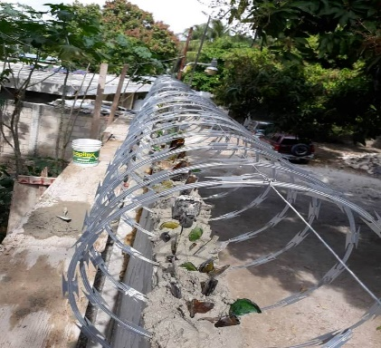
In December, we learned that burglars had scaled the wall around the school and stolen the propane tanks from the new outdoor kitchen and the generator that powered the water and toilets. Friends expressed our concerns for the safety of the staff, students, and occupants of the house as well as the security of the school resources. We sent funds to extend the height of the wall around the perimeter, to add glass shards and barbed wire to the top and to fix the front gate lock to deter further burglaries . Since then, we have learned that the house is secured by iron forges on the windows and doors and is locked after hours so that stored resources are secure. However, we were cautioned to not send any additional resources until next June.
Added security Wall

JANUARY – We distributed Norah Machia’s booklets, written in memory of her father, Michael McHugh. This illustrated documentary of the history and present functioning of Ecole Agape describes our free school for the poor children in Lilavois, Haiti as “A Beacon of Hope!”
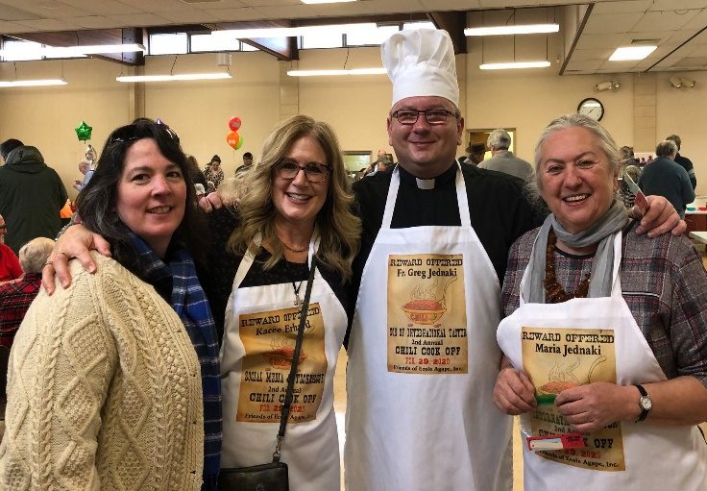
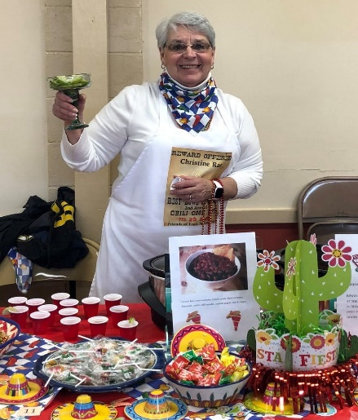
FEBRUARY – On 2/29 we held our Second Chili Cook Off at St Philip’s Parish Center, Ashford. NGO Organizations sent teams of chili chefs to this successful event. We had 19 chili stations with a variety of chilis.
Christine Rae, Ashford Senior Center First Prize Bangin’ Bingo Chili
Maggie Kirk, Kacee Erhard, Father Greg Jednaki, Maria Jednaki
Lynn, chili contestant

Three hundred sixty-seven people sampled the chilis, with one hundred eleven attending their first FEA event ever. The first prize of $250 donated by Attorney Kim Duell went to Christine Rae for the Ashford Senior Center for her “Bangin’ Bingo Chili”; 2nd prize of $150 donated by American Heritage Roofing went to Jeannette Picard for the Village of Children and Families with her “White Chicken Cheddar Chili; 3rd prize of $100 donated by Four Corners Real Estate went to Carol Manning for ‘Neighbors Outreaching Works” for her “You Got Me At Carol’s Chili.” Curtis Brand and the On Call Band and The Daily Campus Band entertained during the tasting and silent auction.
MARCH – JUNE – Rikke Wassenberg and Jane Moynihan organized our members and friends to sew fabric masks which were distributed to St. Philip Church members, health care workers, soup kitchens, treatment centers, shelters, and local organizations. Over 1000 masks were donated.
JUNE – Official notice came from the South Windsor Haiti Group that they were disbanding, citing the inability to provide support. Friends voted to fund the Preschool for the future.
JULY – Friends began meeting via ZOOM which was hosted by Anne Rash. We invited the SWHG members to join our group.
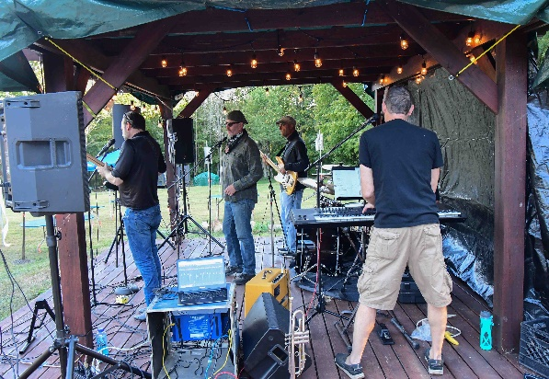
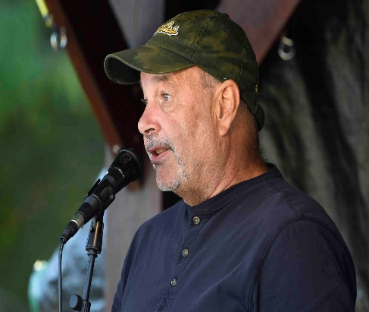
AUGUST – From the South Windsor Haiti Group, Rabbi Jeff Glickman and Mindy Glickman, Saud Anwar, Sheila Appleton, and Elizabeth McGuire joined Friends of Ecole Agape.
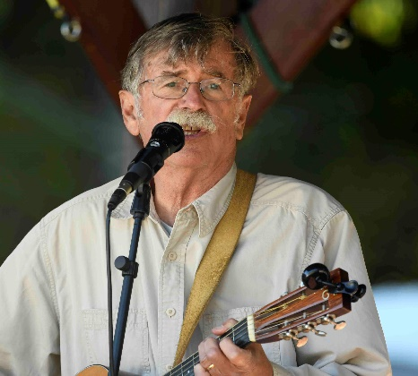
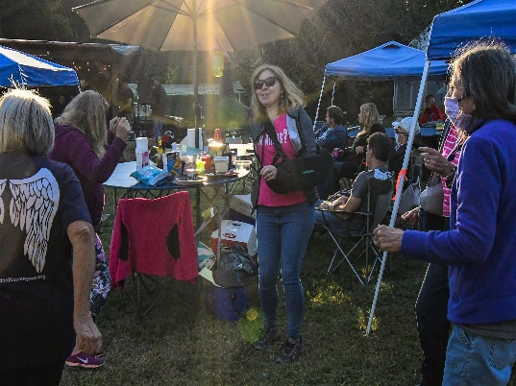
SEPTEMBER – On 9/19 the 5th Annual PIG Roast Sans Pig & Concert was held live on site and was streamed on-line. Outdoor gatherings were restricted to 50 persons at a time. Guests attended with masks, social distanced, and brought their own food and beverages. Many others watched the virtual performance with their guests from the comfort of their homes. Musical talent included Curtis Brand, Hugh Blumenfeld and the Faithful Sky, Karen Lussier, Seldom Heard, and Radio Waves. Kevin White organized and coordinated the talent and provided the sound system while AJ Belanger and Michael Bartron handled the livestreaming. (Top left: Kevin White, Musical Organizer and Coordinator; Top Right: Radio Waves; Bottom left: Dancing Guests; Bottom Right: Curtis Brand)
Dr. Tom Gorin, a founding member of the Haitian Ministry at St. Thomas and a member of FEA, announced that MATH (Medical Aid to Haiti) was sending a large amount of needed medical supplies to Haiti. Individual members contributed to help with shipping cost.
OCTOBER – Mask making continued. These masks were donated to every school in the Windham School District where the school nurses were responsible for their distribution and children’s safe use.
NOVEMBER – Our annual Sponsorship Appeal went out to all donors, contributors, and sponsors. This successful appeal brought in $30,000 in sponsorships and 173 sponsors. Friends of Ecole Agape is very appreciative because of the limited fund raising we were able to do in 2020.
A virtual Wreath Decorating Contest and Silent Auction began the month of November until December 5. A panel of judges (Sue Audette, Cindy Jennerwein, Curtis Brand, Father Greg Jednaki and Father Jonathan Ficara) cast their votes on twenty-six (26) very festive wreaths based on their creativity, visual impact, craftmanship, and message. Attorney Kim Duell, Amy Moore, Mary Weinland, and Anne Rash contributed the prize money. Adult winners: First place to Rikke Wassenberg for “Peace and Meditation”; Second place to Susan Hacking and Michael Bartron for “It’s 5 O’clock Somewhere”; Third place to Judy McChesney for “Peace to All of Good Will”. The adult winners donated their prize money to Ecole Agape. Child winners: First place to Kimber Audette for “Characters of the Season”; Second place to Morgan Tierney for “I Heart Animals”; Third place to Colin Tierney for “Furry Friends.” Kimber Audette donated her prize money to Toys for Tots. Morgan and Colin Tierney donated their money to Homeless Shelter of Vernon.
Kimber Audette, First place
DECEMBER – We received additional donations of 9 new and 13 used sewing machines. Those donating included John Dayton, Amy Moore, Darcy Fox, Lucy Gilson, David and Nancy Westlake, Cindy Moeckel, Kathy Fabian, Mary Wehrle, and Sandra McAlduff. Vinny Audette refurbished, oiled, and repaired the used machines. The machines will be shipped in June of 2021.
Rikke Wassenberg, First Place
Jeannette Picard organized and Jane Moynihan, Maggie Kirk, Judy McChesney and Rikke Wassenberg helped with the setup and manning of the Haiti Awareness booth at the Mansfield Winter Welcome.
Our fifth annual canister campaign, although diminished by the pandemic, added $617.59 to our funds.
We ask you to consider designating Friends of Ecole Agape, Inc. as your charity on Amazon Smile.
We thank you for your support in 2020. We hope that you and your families are safe during the difficult time of this pandemic and have been in touch with family and friends.
We missed you this year and hope to see you at our annual Pig Roast this Fall

Friends of Ecole Agape, Inc. Co-chairs: Michael Bartron, Susan Hacking, Rikke Wassenberg; Treasurer: Larry Grasso and Assistant Treasurer, Ted Hill; Co-Secretaries: Judy Belek, Judy McChesney, and Lillie Tierney; Social Media and Technology Manager Kacee Erhard. Members: Dr. Tom Gorin, Diane Giggey, Mary Anne Brennan, Mary Ertel, Cindy Moeckel, Lucy Hill, Anne Rash, Jane Moynihan, Cathy Belanger, Barbara Pivarnik, Mary Romney, Jeannette Picard, Melissa Stone, Amy Moore, Hannah McKay, Mary Patrone, Maggie Kirk, Peter Kirk, Marie Ann Smith, Judy Melichar, Lorraine Cloutier, Rabbi Jeff Glickman, Mindy Glickman, Saud Anwar, Elizabeth McGuire, Sheila Appleton and Dianne Aborn
Emeritus Members: Mary Wehrle. Dick Long, Paul and Elizabeth Wicks

Please visit our website: www.friendsofecoleagape.org; our Facebook Page; Instagram Account; our email friendsofecoleagape@gmail.com or contact any of our members.
friendsofecoleagape@gmail.com or contact any of our members.

STATEMENT OF INCOME & EXPENSES

For the years ending December 31, 2019 & 2020

2019

2020

INCOME

$ 72,194

$ 62,938

EXPENSES

$ 60,969

$ 39,032

TOTAL CASH

$ 11,225

$ 23,906

DISBURSEMENTS

Salaries: Teacher, Librarian, Food Service

$ 8,580

$ 13,996

Food

$ 9,130

$ 14,922

School Supplies

$ 1,600

$ 1,820

Shipping, Office Supplies, Miscellaneous

$ 1,797

$ 1,037

Computers & Media

$ 0

$

Legal and Filing Fees, Fundraising

$ 6,544

$ 1,424

Solar Lights

$ 1,117

$ 1,535

Wings T
-
shirts, Bags, and Totes

$ 1,371

$ 300

Monogramed Back Packs and Ponchos

$ 1.865

$ 173

Post 6
th

Grade Tuition

Sewing
Machines

$ 700

$ 850

$ 150

School Construction Expenses

$ 28,265

$ 2,825

TOTAL DISBURSEMENTS

$ 60,969

$ 39,032

Net Surplus= income
–

expenses + interest

$12,022

$

STATEMENT OF FINANCIAL POSITION

ASSETS

2019

2020

Cash in Bank

$ 65,644

$ 84,422

Undeposited Cash on Hand

$ 389

$ 4,800

PayPal Receivables

$ 750

$ 600

Solar Lights

$ 475

$ 600

Haitian Crafts

$ 500

$ 500

Wings T
-
shirts, bags, blankets

Sewing Machines and Supplies

$ 1,632

$ 1,332

$ 1,650

TOTAL ASSETS

$ 69,360

$ 93,904

LIABILITIES & FUND BALANCE

2019

2020

General Fund Balance

$ 69,390

$ 93,904

TOTAL LIABILITIES & FUND BALANCE

$ 69,390

$ 93,904

Details of School Construction Expenses for 2019

2019

2020

Front Entrance Rehabilitation

$ 482

Puisard (Pump)

$ 495

Plumbing Supplies

$ 2,683

Other sanitary block construction

$ 12,285

Exterior Kitchen

$ 1,409

Pump installation

$ 965

Benches and Tables Materials & Labor

$ 5,531

Blackboards

Perimeter Wall Enhancement

$ 75

$ 2,825

TOTAL
CONSTRUCTION DISBURSEMENT

$ 28,265

$ 2,825

