Friends of Ecole Agape, Inc.
2017 ANNUAL REPORT
The Friends of Ecole Agape, Inc. appreciates you. Whether you sponsored a child, attended fundraisers, purchased solar lights for students, contributed to the canister campaign, spread awareness with the purchase of WINGS tee-shirts, or donated time, goods or services, you gave Ecole Agape financial stability that exceeded all expectations.
This academic year, enrollment increased from 222 to 275 students, with the addition of 33 preschool and 20 first through sixth grade students. A new afternoon preschool enrolled 25 teenage girls. In grades 1 through 6, sixty-one percent (61%) of the students live with and work in other families’ homes because their own family cannot afford to care for them. Known as Restavecs, these students are “unpaid child laborers trapped in a modern form of slavery” (United Nations). Education will help to break this tragic cycle of poverty.
This year, Friends of Ecole Agape financially supported five graduates of Ecole Agape to matriculate into the seventh grade at another school. One student, denied further education by Haitian public-school policy because of a prior pregnancy, was only able to continue her education through Ecole Agape, an alternative school.
The teachers attended two in-service seminars to learn: Class Management, Educational Evaluation and How to Deal with Over-age Children. Teacher feedback revealed how well received and helpful the seminars were. Furthermore, the teachers reported that the increased variety and abundance of grade level books, the growth of the flash library, and additional supplies have vastly increased their effectiveness.
The Friends of Ecole Agape became a larger, stronger, and more versatile group in 2017. Michael Bartron, Susan Hacking, Margaret Judy, Peter Kirk, Judy McChesney, Amy Moore, Jeannette Picard, and Melissa Stone joined the Friends of Ecole Agape. With their individual talents, each helps to continue Myrtha Manigat’s dream to educate and feed the poorest of the poor children in Haiti.
FRIENDS ACTIVITIES
Sponsorships The number of sponsors increased 46%, from 65 sponsors in 2016 to 95 sponsors in 2017. With some sponsors supporting more than one child, the income increased 139%, from $11,700.00 to $28,000.00.
Events
January. Larry Grasso, Cindy Moeckel, Ted and Lucy Hill traveled to Haiti at their own expense and carried books and supplies for the Ecole Agape Flash Library.
February. Paul and Liz Wicks, of the Reading Room, conducted a teacher training seminar at Ecole Agape. The teachers participated in the set up the Flash Library, were educated in the use of the library, and a full-time librarian was hired. Participating Ecole Agape teachers and Preschool teachers received a certificate of completion, as well as a bonus.
March. The First Annual Wine Tasting occurred in St. Philips Center in Ashford. CT. Guests were treated to superior musical performances by Seldom Heard (Lee Terry, Tom Terry and Howard Drescher) and the On Call Band (Curt Brand, John Hand and Mark Campbell). Mike Patel, owner and operator of Columbia Package Store provided guests with a sampling of wines that varied by grape DNA, region, and price. Accolades go to Amy Moore, owner and operator of American Eagle Saloon and sous chef Diane Giggey who created the menu of delicious hors d’oeuvres and presented the variety of homemade desserts. Special acknowledgment goes to the Patrons of our First Annual Wine Tasting, a group of Women Family Law Attorneys who have a special commitment to the best interest of children in the court.* Guests purchased Haitian Art and Crafts and enjoyed Tony Machia’s photographic display that captured the essence of Ecole Agape Students and their community.
June. Friends of Ecole Agape, their families, and friends enjoyed pizza, music, and fellowship at Blaze Pizza in Storrs Center. Blaze Pizza donated 20% of the cost of all the pizzas purchased to Ecole Agape.
The Connecticut Chapter of Altrusa International, spear headed by Anne Rash, launched their ongoing solar light initiative: Buy One Solar Lantern, Gift One to Ecole Agape. The lights were sent to Haiti.
Two water filtration systems developed by Matthew Lisle, grandson of Ruth Moynihan, were sent to Ecole Agape. Ruth and her daughter Elaine Lisle paid the shipping fees. The students now have clean, drinkable water.
July and August. A book camp showcased the Flash Library and extended the school year for 92 students who attended the camp.
August to December. Canisters, placed in local businesses and homes, produced $1,800.00, earmarked for solar lights and additional school supplies.
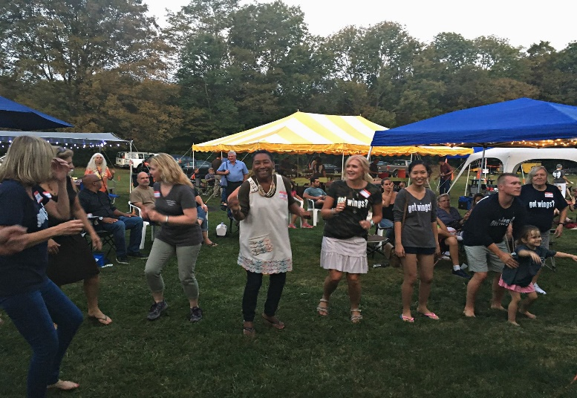
September. The Second Annual Pig Roast took place September 16 at Rikke Wassenberg’s home. The highlight of the day was the presence of Marie Michele Darbouze and Chantal Coutard, the two administrators of Ecole Agape. The guests were delighted to meet, party, and dance with Marie Michele and Chantal. Amy Moore organized and coordinated the abundant food and drink tent with foods donated by local businesses as well as the American Eagle Saloon**. John Erhard and Jeff Roets were exceptional pit masters. Kevin White organized and provided the sound system for over six hours of continuous live musical performances featuring: Belle of the Fall, Hugh Blumenfeld, Bruce John, Radio Waves and Who We Are. Nathan Picard-Buskey was the sound Engineer. *** Kiosks featured information about Haiti, sponsorships, solar lights and tee-shirt sales.
Marie Michele and Chantal met with members of Friends of Ecole Agape, reviewed Ecole Agape’s past year’s changes and accomplishment, and set goals for the upcoming school year. Since funds have been provided directly to the school for the purchase of food, the quality, quantity, and variety has improved with more vegetables and meat to augment the previous menu of rice, beans, plain spaghetti, corn and herring. The administrators returned to Haiti with almost two hundred solar lights, backpacks and our best wishes.
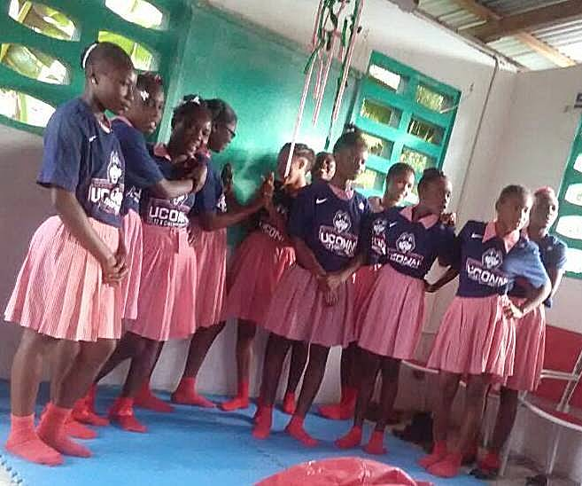
Friends of Ecole Agape made their first presence at Celebrate Mansfield Festival and Parade. Kacee Erhard and Jeannette Picard operated the booth that provided information about Haiti, Ecole Agape, collected $135.00, and added the names of twenty-six people to our events list.
October. A barrel, packed with tee-shirts donated by UConn Co-op, water filters, books, CD’s, and a bookbinding machine was sent to Haiti. Valerie Sakowski, a loyal contributor, paid the shipping fees.
December. The December 8th Annual Meeting of Friends of Ecole Agape, acknowledged contributions of new members and the work of Kacee Erhard by adding her position of Social Media and Technology Manager to the Board of Directors.
Friends shipped a double food supply in December so that each student could gift their family with food. The Director, Teachers, Librarian and Food Service workers received double their salaries as a Christmas bonus.
Persons who donated their treasure, time and/or talent.
* Attorneys: Pam Bacharach, Caryl Balskus, Melissa Morin Donahue, Kim Duell, Ceil Gersten, Karen Gersten, Evelyn Gryk, Susan Lee Heintz, Kate Haakokonsen, Kate Kowalyshyn, Fatima Lobo, Lynne Ustach and Christine Whitehead.
Musicians: Lee Terry, Tom Terry and Howard Dresher of Seldom Heard. Curtis Brand, Jon Hand, and Mark Campbell of the On Call Band
** Businesses: American Eagle Saloon, American Heritage Roofing, LLC, Big Y, Dog Lane Café, Domino’s Pizza, Dunkin Donuts, Ed and Susan Passmore, Gansett Wraps, Great Harvest Bread Company, Grille 86, Hosmer Mountain Soda, Kathmandu Kitchen & Bar, Mooyah’s Burgers, Fries & Shakes, Ruth Buczynski, PhD of the National Institute for the Clinical Application of Behavioral Sciences, The Packing House, Price Chopper, Restaurant 99, Spring Hill Café, Skin Essentials Day Spa, Starbucks, Storrs Therapeutic Massage, and Willington Pizza.
*** Musicians: Tracy Walton and Julia Autumn Ford of Belle of the Fall; Bruce John of Bruce John Music, Hugh Blumenfeld, MD, PhD of Blumenfeld Music, Mike McDonald et al. of Radio Waves, and Carl Booth, Frank Busse, Kevin White, John Jeff and William Quinn of Who We Are. Sound Engineer, Nathan Picard-Buskey.
2017 FINANCIAL STATEMENT
Statement of Income and Expenses |  |  |  |  |  |  | Statement of Financial Position
For the Years Ending December 31, 2016 & 2017 |  |  |  |  |  |  | For the Years Ending December 31, 2016 & 2017
 |  |  | 2016 |  | 2017 |  | Assets |  |  | 2016 |  | 2017
INCOME |  |  | $29,822 |  | $49,585 |  | Cash in Bank |  |  | $12,907 |  | $19,372
EXPENSES |  |  | 20,548 |  | 39,097 |  | Undeposited cash on hand |  |  | 510 |  | 1,975
TOTAL CASH: |  |  | $9,274 |  | $10,488 |  | Accounts Receivable: PayPal |  |  | 314 |  | 1,036
 |  |  |  |  |  |  | Haitian Crafts |  |  | 0 |  | 546
 |  |  |  |  |  |  | "Got Wings" t-shirts |  |  | 0 |  | 1,290
ACTIVITY DISBURSMENTS |  |  | 2,016 |  | 2,017 |  | Total Assets |  |  | $13,731 |  | $24,219
Salaries - Teacher, Food Service & Librarian |  |  | $4,750 |  | $7,360 |  | Liabilities & Fund Balance
(This includes a 10% raise and Christmas Bonus) |  |  |  |  |  |  | General Fund Balance |  |  | $13,731 |  | $24,219
Food |  |  | 9,960 |  | 14,110
Supplies |  |  | 1,600 |  | 1,600
Haiti Outreach Diocese |  |  | 1,763 |  | 2,969
Shipping, Office supplies & Miscellaneous Program Expenses |  |  | 907 |  | 1,093
Legal Fees, Filing Fees, Insurance & Fundraising |  |  | 1,568 |  | 5,628 |  |  |  |  | 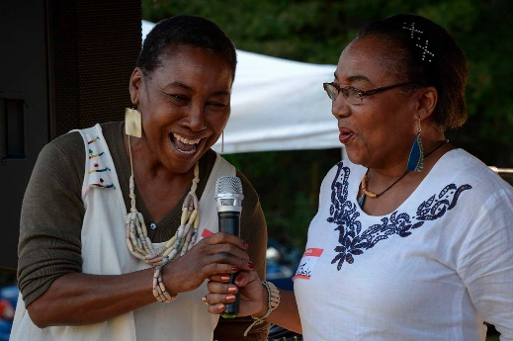
Solar Lights -illumination, awards for academic performance & parental participation |  |  | 0 |  | 3,500
Wings T-Shirts (gratis to sponsors and for sale) |  |  | 0 |  | 2,032
Post 6th grade tuition for Ecole Agape Graduates |  |  | 0 |  | 805
TOTAL ACTIVITY DISBURSMENTS |  |  | $20,548 |  | $39,097

As we begin 2018, we hope you will join Friends of Ecole Agape as we continue our support of Ecole Agape, the only free all-girls’ school in Haiti.
Friends of Ecole Agape, Inc. Members: Mike Bartron, Cathy Belanger, Judy Belek, Mary Anne Brennan, Kacee Erhard, Mary Ertel, Diane Giggey, Larry Grasso, Susan Hacking, Lucy Hill, Ted Hill, Maggie Judy, Peter Kirk, Dick Long, Mike McHugh, Judy McChesney, Cindy Moeckel, Amy Moore, Ruth Moynihan, Jeannette Picard, Barbara Pivarnik, Anne Rash, Mary Romney, Philip Schaab, Melissa Stone, Lillie Tierney, Mary Wehrle, Rikke Wassenberg, and Members at Large, Tom Gorin, Pat Murphy, Elizabeth Wicks, and Paul Wicks.
http://www.friendsofecoleagape.org
https://m.facebook.com/friendsofecoleagape
https://www.instagram.com/friendsofecoleagape/

