Annual Report 2018
Friends of Ecole Agape, Inc

2018 proved to be another successful year for Friends of Ecole Agape, Inc. Throughout 2018, Friends of Ecole Agape, Inc. received support from 59 sponsors and over 300 contributors. We greatly appreciate the support of our sponsors, contributors, members and our surrounding communities. Without their support, many students would not have the opportunity for a structured education and better future.

In 2018, we had three financially successful fundraisers that attracted new patrons and promoted a growing awareness of Haiti. Friends of Ecole Agape became a larger, stronger and more versatile group in 2018. Hannah Thompson, Jane Moynihan and Mary Patrone joined us, adding their individual talents.
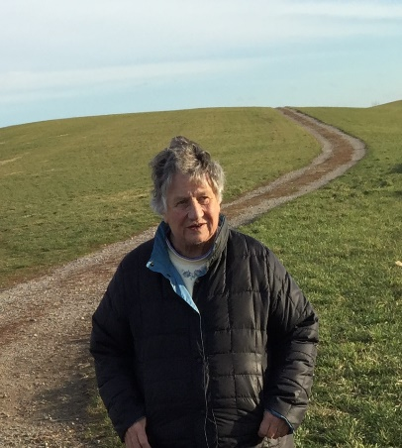
REMEMBERING RUTH MOYNIHAN October 1st we lost our beloved Ruth Moynihan, an early leader of the Social Justice Committee at St. Thomas Aquinas and a founding member of the Haitian Ministry in 1989. Ruth developed and spearheaded the sponsorship program that developed into the Haitian Children’s Fund in 1995. She was an active and tireless leader in all facets of the ministry—fundraising, outreach, record keeping, report writing and a generous financial donor. After the St. Thomas Haitian ministry was dissolved in 2015, Ruth continued her support of Haiti as a founding member of Friends of Ecole Agape, Inc. As Friends evolved, Ruth consistently kept us on task. Always the historian, she reminded us that our work, past, present and future, should be “all about the girls;” with the focus on their education, development and future as citizens capable of giving back. With 30 years of service to the poor in Haiti, Ruth will be missed for her insights, her calm and her presence at our meetings.

ECOLE AGAPE: THE STUDENTS In the 2017-2018 academic year, 247 students attended the first day of school. Throughout the school year, 31 students stopped, while 29 students enrolled. At the end of the school year there were 245 students.

Attendance was affected by several events. July saw unrest, street blockades and violent riots over fuel price increases. Residents were required to take “shelter in place,” and the summer book camp had a delayed start with attendance suffering. In October there was an earthquake north of Port au Prince, and anti- corruption protests in November and December. With the widespread civil unrest, some families returned their children to their hometowns for safety.

The changed schedule at “La Providence” resulted in our students losing an hour of instruction time each day. With only three hours available, the time was not adequate for learning. It became apparent that we needed to build our own school to have the time necessary for instruction and mastery of the curriculum.

The students were enthusiastic participants in two reading competitions at the end of 2017 and beginning of 2018. The successful participants received solar lights donated by FEA for their homes. Friends of Ecole Agape also continued their financial support of the five Ecole Agape graduates who successfully completed the seventh grade and matriculated into the eighth grade. One student moved to Chile, so we will support four students in 2019.

ECOLE AGAPE: THE TEACHERS FEA is committed to continuing education for teachers. Three workshops were presented: 1) Reading as a Transverse Educational Tool; 2) The Use of the Laptop in School Apprenticeship; and 3) Instructional Activities and Curriculum Development for 2018 Summer Camp. Teachers received $20.00 stipends for their participation.

Two Ecole Agape teachers Rachelle Ducoste and Islande Louis attended a course at a professional school, completed their degrees, and received Teaching Licenses.
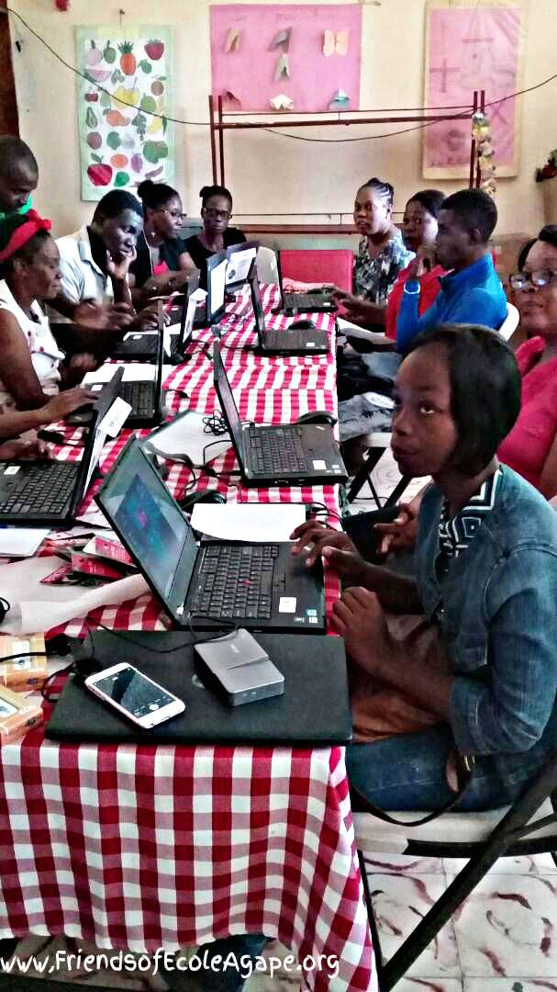
JANUARY We secured folding chairs from St. Mary’s and UConn surplus. We now have over 120 chairs and 16 round tables purchased from St. Jude’s available for FEA events.

FEBRUARY We sent an oversized barrel to Haiti, valued at over $2,000 which included large portable dry erase boards for teachers, smaller dry erase boards for students, markers, erasers, solar lights, 117 books for the library, paper supplies, ball point pens, pencils, game pouches from Rabbi Glickman, and colored ink cartridges.

MARCH FEA implemented an administrative cost savings by using direct wire transfers from Key Bank to a Bank in Haiti. This change eliminated the 10% administrative fee previously paid by FEA to Outreach to Haiti.

Twelve refurbished laptops loaded with Microsoft Office 10 were purchased from a non-profit specializing in charitable computer recycling and use, www.InterConnections.org. FEA’s “Adopt and Name a Computer Campaign” raised enough to cover the cost for all the computers within the month. Now each Ecole Agape teacher has his/her own laptop to facilitate instruction. Additionally, friends of Attorney Kim Duell honored her birthday by presenting FEA funds to create a mobile media center with the purchase of a Miroir Smart Tilt Projector, a computer with a speaker attached, as well as flash drives and a mouse for each teacher’s computer.

APRIL The April 7 Wine Tasting was a financial success earning over $13,500. Ashford Spirits donated the wine for tasting; Anna Knuttel donated flower arrangements for each table; David Palmer donated the proceeds of his chair massages; and Bruce John donated the music. Amy Moore not only prepared the hor d’oeuvres, but she also organized and coordinated the food donated by local businesses: Alladin Mediterranean Grill, Gansett Wraps, Subway, Katmandu Kitchen & Bar and Restaurant 99. Marie Michele and Chantal brought art and crafts from Haiti, attended the event, and returned to Haiti with the twelve computers, the mobile media center equipment and solar lights.

MAY On May 19, Friends of Ecole Agape members gathered their leaf blowers, rakes, brooms, clippers, saws and wheelbarrows for a spring clean-up at St. Philip’s grounds.

JUNE The doors to our First Comedy Night opened at 6:30 pm on June 22, with AJ Belanger in the sound booth and music by Karen Bushey Lussier. Rebecca Anne Lo Cicero was master of ceremonies. Dr. Jay Sutay was the featured comedian with opening by comedian Joe Pontillo. Tickets were $25.00 in advance and $30.00 at the door. This event was the first time Friends of Ecole Agape had a 50-50 raffle and the ticket price was fixed, not a free will offering. The amount raised was approximately $3,000.

Fourteen more laptops with Microsoft Office 10 were purchased for student use in the classroom.

JULY The Blaze Pizza Fundraiser during Mansfield Summer Concert Series had a low turnout due to inclement weather. Next summer be on the lookout for more Blaze Pizza events.

Furnishing and supplies that were due to be discarded by several local schools were retrieved and redistributed to schools in Willimantic, Manchester, Hartford, North Grosvenordale and Lilavois, Haiti.

AUGUST Friends of Ecole Agape members volunteered for setup, ticket sales, beverage sales, security and traffic control at the Jillson Square Concert featuring Jose Feliciano and Peabo Bryson. The Concert was for the benefit of Generations, a non-profit health care provider.

Friends of Ecole Agape purchased ninety-six Inflatable Solar Lights with USB Ports. As a recognized humanitarian organization, we purchased the lights at a reduced price. The “Keep One and Gift One to Haiti” Campaign was launched.

Members sanded and painted the circular tables purchased from St. Jude’s for use at FEA events.

SEPTEMBER Third Annual Pig Roast and Concert was a success, raising over $13,000.00. Over 300 persons attended, with 117 attending an Ecole Agape event for the first time. For the third year, Kevin White provided and organized the musical Talent: Curt Brand; Hugh Blumenfeld, My Brother’s Basement (Barb Lavoie, David Lescoe, Ernie Rocco, Mark Scully, John Whitcomb), Seldom Heard (Howard Drescher, Lee Terry, Tom Terry), Temporary Sanity Band (Zoe Bates, Jake Baynes, Mark Borenstein, Kelly Conway, Nat Brinn, Ed Jurkiewicz, Mark Scully, Henry Withers), Who We Are (Kevin White, Frank Busse, John Jeff, William Quinn), and Karen Bushey Lussier provided 6 hours of continuous live music. Nathaniel Picard-Busky was the audio engineer.
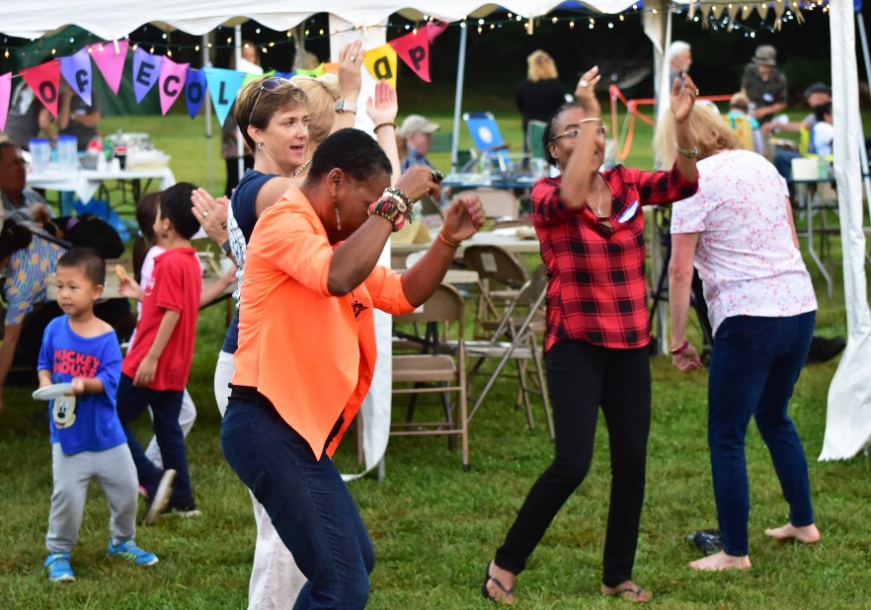
Amy Moore not only prepared food but organized and coordinated the food and drink tents with foods donated by local businesses: American Eagle Saloon, Dog Lane Café, Dominos Pizza, Dunkin Donuts, Gansett Wraps, Kathmandu Kitchen and Bar, Price Chopper, Red Rock Café, Restaurant 99, Spring Hill Café, Starbucks, and Willington Pizza.

John Erhard and Jeff Roets, our skilled pit masters, roasted the pig donated by Ed and Susan Passmore. Kiosks featured solar lights, “Got Wings?” Tee-shirts and bags, information about Haiti and sponsorships, as well as chair massage by David Palmer. Major financial sponsors were Altrusa of Northeastern Connecticut, American Heritage Roofing, Mansfield Supply, St. Philip’s Church, and Therese Nakken.

Marie Michele Darbouze and Chantal Coutard, administrators of Ecole Agape, our featured guests, met with FEA to review the 2017-2018 school year, returned to Haiti with additional computers to establish a computer lab for students, as well as solar lights with USB ports capable of charging computers and cell phones.

Jeannette Picard staffed an Ecole Agape booth at the Celebrate Mansfield Festival and Parade for the second year-- increasing awareness of Haiti through games, letter writing and posters.

OCTOBER A second barrel was sent to Haiti with school supplies, pens, pencils, essay booklets for storytelling, writing tablets for learning the alphabet, math tools for learning the concepts of time, measurement, and counting. Yarn, knitting and crochet needles were included for students to use for developing fine motor skills and preparing for future life skills.

NOVEMBER Our membership voted to start a capital campaign to build additional classrooms for Ecole Agape. The family of Ruth Moynihan presented $15,000.00 in loving memory of their wife, mother, and grandmother. Friends and family gave an additional $5,000.00. Ruth continues to be an inspiration for us. A classroom will be named in her honor. Ruth will always be in Haiti.

DECEMBER Our second canister campaign was successful, raising more than $2,800, with canisters placed in homes of individuals as well as businesses.

STATEMENT OF INCOME & EXPENSES
For the years ending December 31, 2017 & 2018
2017 2018
INCOME $ 49,585 $ 73,376
EXPENSES $ 39,097 $ 40,227
TOTAL CASH $ 10,488 $ 33,149

DISBURSEMENTS 2017 2018
Salaries: Teacher, Librarian, Food Service $ 7,360 $ 8,580
Food $ 14,110 $ 14,110
Outreach to Haiti $ 2,969 $ 1,512
School Supplies $ 1,600 $ 3,746
Shipping, Office Supplies, Miscellaneous $ 1,093 $ 454
Computers & Media -------- $ 3,895
Legal and Filing Fees, Fundraising $ 5,628 $ 4,319
Solar Lights $ 3,500 $ 1,514
Wings T-shirts, Bags, and Totes $ 2,032 $ 1,397
Post 6th Grade Tuition $ 805 $ 700
TOTAL DISBURSEMENTS $ 39,097 $ 40,227

STATEMENT OF FINANCIAL POSITION
ASSETS 2017 2018
Cash in bank $ 19,372 $ 52,727
Undeposited Cash on Hand $ 1,975 $ 715
PayPal Receivables $ 1,036 $ 664
Solar Lights $ -------- $ 350
Haitian Crafts $ 546 $ 660
Wings T-shirts, bags, blankets $ 1,290 $ 2,252
TOTAL ASSETS $ 24,219 $ 57,368

LIABILITIES & FUND BALANCE
Building Fund $ -------- $ 20,328
General Fund Balance $ 24,219 $ 37,040
TOTAL LIABILITIES & FUND BALANCE $ 24,219 $ 57,368

As we begin 2019, we thank you for your support in 2018; invite you to our events; ask you to consider sponsoring a child; and share your talents by becoming a member of Friends of Ecole Agape.

2019 promises to be our most challenging year yet. The civil unrest in Haiti and the limitation of classroom time at La Providence School for Ecole Agape students has challenged our ability to provide a quality education. We need to restore the structural integrity of Myrtha Manigat’s house that was damaged in the 2010 earthquake and create additional classrooms to make certain our students have the space needed.

Friends of Ecole Agape, Inc. Co-chairs: Michael Bartron, Susan Hacking, Rikke Wassenberg; Treasurer: Larry Grasso & Assistant Treasurer, Ted Hill; Co-Secretaries: Judy Belek, Judy McChesney, Lillie Tierney; Social Media and Technology Manager, Kacee Erhard. Members: Mary Wehrle, Dr. Tom Gorin, Michael McHugh, Pat Murphy, Diane Giggey, Dick Long, Mary Anne Brennan, Mary Ertel, Cindy Moeckel, Lucy Hill, Anne Rash, Jane Moynihan, Cathy Belanger, Barbara Pivarnik, Paul Wick, Elizabeth Wicks, Mary Romney, Philip Schaab, Jeannette Picard, Melissa Stone, Amy Moore, Hannah Thompson, Mary Patrone, Maggie Judy and Peter Kirk.

Please visit our website: www.friendsofecoleagape.org; our Facebook Page, our Instagram account, our email friendsofecoleagape@gmail.com, or contact any of the members.

