Friends of Ecole Agape, Inc.
Annual Report – 2016
The Friends of Ecole Agape, Inc. thank you not only for your financial gifts when you sponsored a child, attended our fundraising events, and made generous free will offerings but also for your gifts of donated goods, services and time. This is our first annual report as a 501(c) 3 non-profit. For your information we have provided information about our origin.
The Pastor of St. Thomas Aquinas Church dismissed the members of the Haitian Ministry Committee in September of 2015, with the exception of his appointed chairperson who was to shepherd the Haitian ministry through its discernment and reorganization at a later date. The dismissed members of the Haitian Ministry met and unanimously voted to form a non-profit organization to continue supporting Ecole Agape, by supplementing the reorganized Haitian Ministry. On 23 November of 2015, Friends of Ecole Agape was incorporated. Our goals: 1) teacher training for the staff of Ecole Agape; 2) increasing teachers’ salaries; and 3) establishing a Flash Library with Paul and Elizabeth Wick’s non-profit, The Reading Room. In February of 2016, the twenty year old Haitian Ministry at St Thomas Aquinas was not reorganized, but was dissolved.
Friends of Ecole Agape affirmed their commitment to Ecole Agape and founder Myrtha Manigat’s dream: To provide an education and one substantive meal a day at no cost to the poorest of the poor. We unanimously voted to assist the two administrators Marie Michele Darbouze and Chantel Coutard in their commitment to keep the doors of Ecole Agape open after the death of Myrtha Manigat.
We strengthened our relationship with the Members of the South Windsor Haiti Group who support the Preschool, with Paul and Elizabeth Wicks who provide teacher training and educational materials through The Reading Room, and with Outreach to Haiti who oversees and facilitates programs from the United States in Haiti. Communication and cooperation with these groups has been essential for a smooth transition as we committed to meet the financial, educational and nutritional needs of the 222 students and 11 teachers at Ecole Agape and the Preschool.
ACTIVITIES
Sponsorship This has traditionally been the main source of funds for Ecole Agape. A sponsor commits to a yearly pledge of $180 to support a child’s education. Currently we have 65 sponsors, some of whom fund more than one child, producing $11,700 in revenue. There is a need for more sponsors. The ideal number of sponsorships would create a yearly income stream of $25,000.
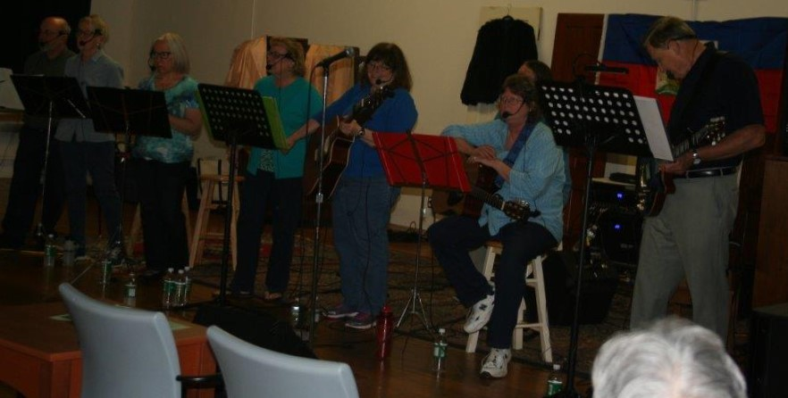
Fund Raising

Spring for Haiti. May - The group “Evidence of the Resurrection” sing in an evening of contemporary Christian music, ending with a silent auction at the Packing House in Willington.

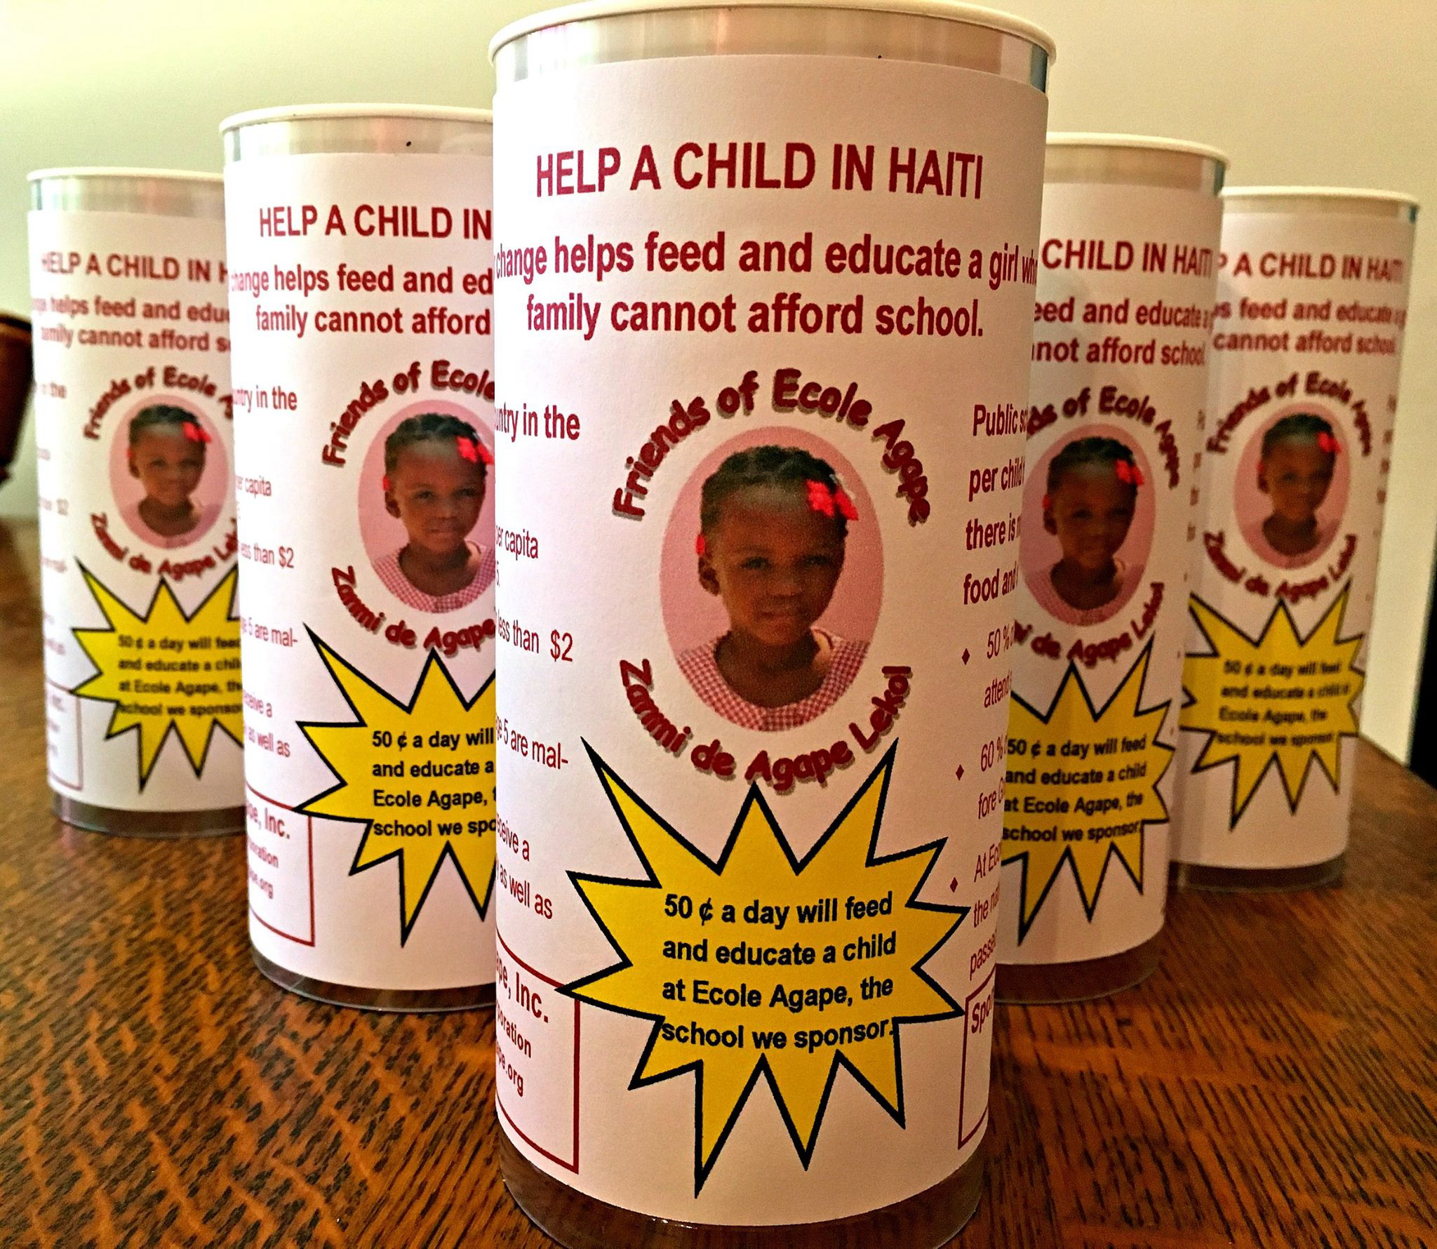
Canister Collection. By placing canisters in local businesses and individual homes, the charity canister campaign produced $1,480 in 2016. In 2017, the canisters will be placed in different businesses and homes.

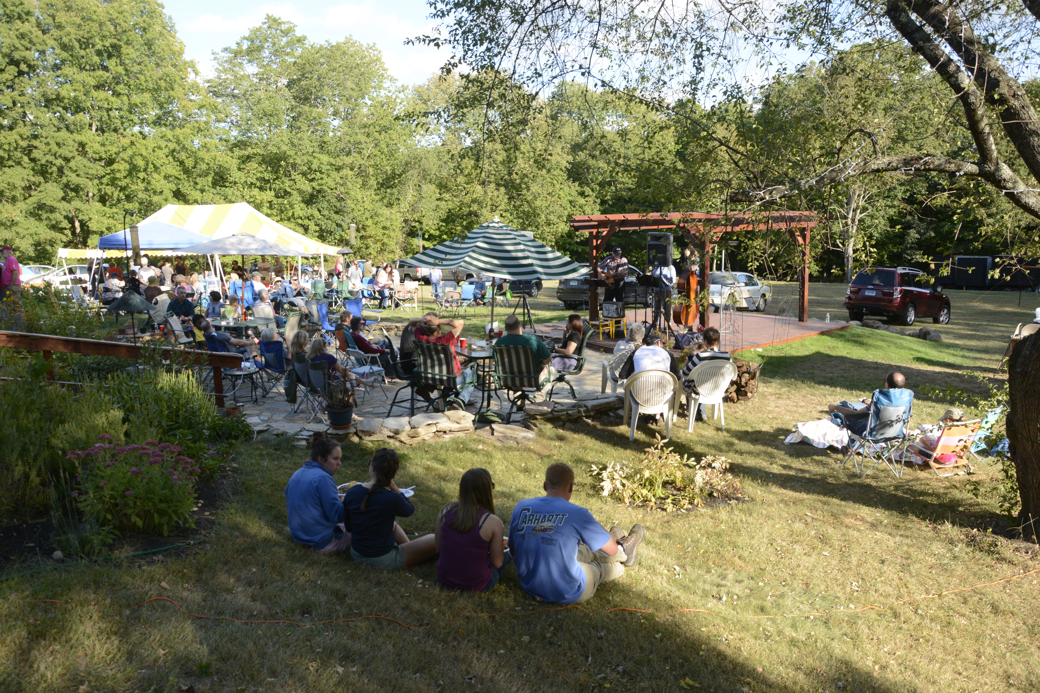
Pig Roast. September. Musical Groups, “Seldom Heard”, “Who We Are” and “A Day Less” shared their talents and music throughout the day.
Grill Master John Erhard presented the main dish—a 230 pound pig roasted to perfection, while the Friends of Ecole Agape provided a variety of sides and desserts as well as dishes for vegetarians and the gluten free.

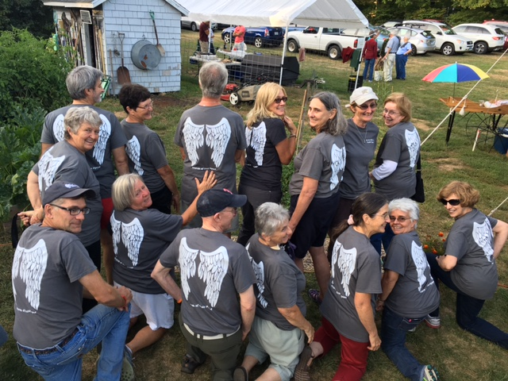
Distinctive Tee Shirts. “Be an Angel to Ecole Agape in Haiti”
The Shirts are available at our events or on our website with a free-will offering. These shirts have increased the awareness of our mission in Haiti, demonstrate the solidarity of those who wear them, and have attracted sponsors.

Friends of Ecole Agape, Inc. is a registered charity on Amazon Smile. Select Friends of Ecole Agape, Inc. as your charity in order to have 0.5% of eligible purchases donated. Click on this link to find Amazon Smile: https://smile.amazon.com
Haiti Awareness
Videotapes Barbara Pivarnik traveled to Haiti in November to
Video-tape the Preschool, Ecole Agape, and its graduates.
The tape’s intent is to increase awareness and attract more sponsors
A Website, Facebook Page, and Brochure were created to enhance
awareness, provide information, and methods for contact.

ACCOMPLISHMENTS
- We met monthly budgets for supplies, teacher salaries, food, and school maintenance.
- Friends of Ecole Agape and the South Windsor Haiti School group sent a check for a 10% increase in teachers’ salaries, retroactive to September. This bonus was a wonderful surprise for the teachers.
- A generous sponsor provided funds for a special Christmas Dinner for the students.
- We sent a double food order in December for the students to share with their families.
- In December, we hosted the visit to Connecticut of Marie Michele Darbouze and Chantal Coutard. At the full day conference also attended by the South Windsor Haiti Group and the members of the Reading Room, our visitors vivid description of the school and students helped us to understand their daily challenges, how we could be of help and the importance of keeping Mrytha’s dream alive. At the 25th Anniversary Celebration of Ecole Agape at the home of Fran Archambault and Barbara Pivarnik, Marie Michele and Chantal expressed their heartfelt thanks to each and every generous supporter.
As we begin 2017, we hope you will join us as a Friend of Ecole Agape as we continue our vital support of our school.

Friends of Ecole Agape, Inc. Members: Ted Hill, Chairperson; Rikke Wassenberg, Associate Chairperson; Larry Grasso, Treasurer; Lillie Tierney, Secretary; Mary Wehrle, Ruth Moynihan, Dr. Tom Gorin, Judy Belek, Diane Giggey, Dick Long, Mary Ann Brennan, Mary Ertel, Cindy Moeckel, Lucy Hill, Kacee Erhard, Anne Rash, Cathy Belanger, Barbara Pivarnik, Fran Archambault, Paul and Liz Wicks, Mike McHugh, Pat Murphy, Mary Romney and Philip Schaab.

Visit Friends of Ecole Agape at our Website: www.friendsofecoleagape.org ; Facebook Page: Friends of Ecole Agape, Inc., or contact us by e-mail at friendsofecoleagape@gmail.com.
FINANCIAL REPORT, END OF YEARS, 2015,2016
Receipts | 2015 | 2016 |  | Assets | 2015 | 2016
Donations | $4,470 | $29,822 |  | Cash in Bank | $2,957 | $12,907
Program expenses |  |  |  | Undeposited cash on hand | 1,500 | 510
Teacher salaries | $- | $3,457 |  | Accounts Receivable: PayPal | - | 314
School supplies | - | 1,600 |  | Total Assets | $4,457 | $13,731
Food preparation salaries | - | 1,293 |  | Liabilities & Fund Balance
Food | - | 9,960 |  | GENERAL FUND BALANCE | $4,457 | $13,731
Christmas food and gifts | - | 520
Pre-school support | - | 180
Program administration | - | 1,763
Total program expenses | $- | $18,773
Other expenses
Office supplies and postage | $13 | $207
Insurance | - | 250
Fund raising expenses | - | 868
Legal and filing fees | - | 450
Total other expenses | $13 | $1,775
Net Surplus | $4,457 | $9,274

