ANNUAL REPORT 2021
FRIENDS OF ECOLE AGAPE, INC
Friends of Ecole Agape (FEA) is grateful for the loyal and continued support of so many generous donors and sponsors. Despite another year of the corona virus, we held several community fundraisers: the sale of Munson’s Fine Chocolates, the 6th Annual Pig Roast and Concert, and the 2nd Annual Wreath Decorating Contest and Silent Auction. Friends welcomed a new member, Leigh Gwara. Several members applied for Emeritus Membership status which was granted.
Ecole Agape Students
Despite the COVID Pandemic, political unrest, kidnappings, fuel shortages, protests, an earthquake and a hurricane, Ecole Agape was in session in 2021 with minor interruptions from January to July 7; and July 12- August 1 for Summer Camp and in the fall from September 13 to December 17.
One hundred thirty students attended grades 1-6; eighty-three students attended preschool. FEA and sponsors provided secondary school tuition for eleven students with ten completing the year, while one student’s family moved away. In addition to completing the regular curriculum, students celebrated three Haitian Holidays for the first time in their very own school: National Teachers Day on May 17th, Haitian Flag Day on May 18th, and Environment Day on June 5th.
The students attending Summer Camp concentrated on computer science, reading, and handcrafts. The Director, Ginette Cassius, used the Summer Camp to complete and reinforce the school program with 4th, 5th, and 6th graders to ameliorate the gaps in subjects affected by adverse conditions throughout the year.
The students had their Annual Christmas Party, with gifts and a special meal in December. The teachers were grateful to receive a bonus and a bottle of red wine.
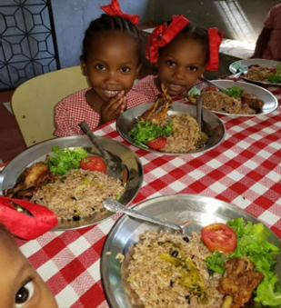
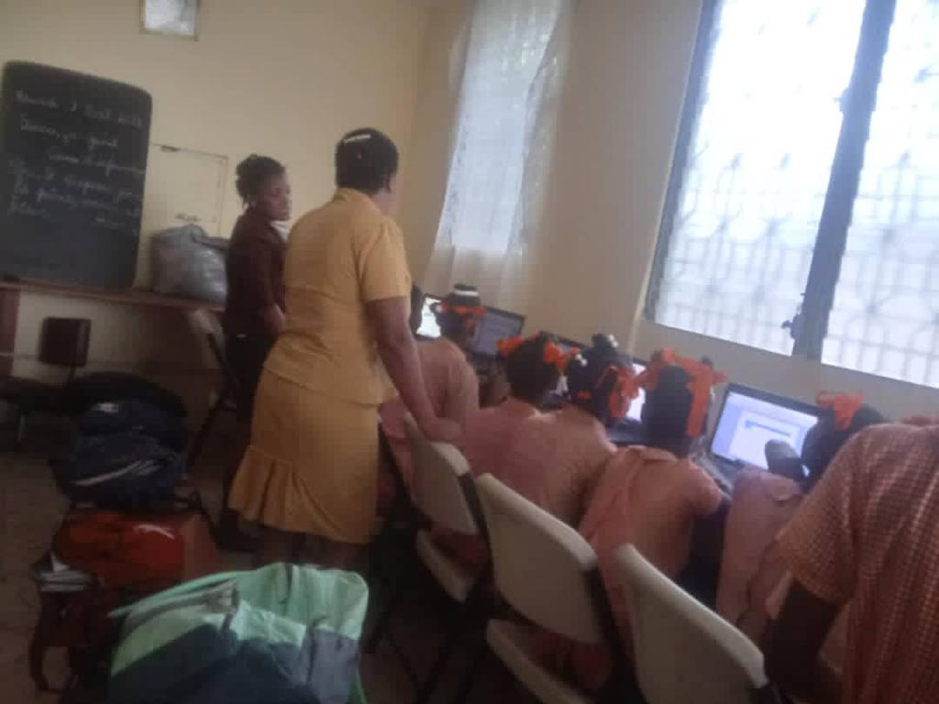
Ecole Agape School
The new buildings - library, classrooms, outdoor kitchen, and sanitary block - are now secure and in daily use. The computer lab is up and running. Students in the 4th, 5th, and 6th grade were excited to use the Microsoft Word program, conduct research on the internet, text, and modify the screens on their computers. The school email, agapecol2021@yahoo.com, allows FEA members to send letters to individual grades and teachers that promote an active, ongoing exchange. Ginette is in the process of replacing Mr. Lammare, a 6th grade teacher, and the school’s librarian, Clecia.
Marie Michele Darbouze submitted a successful grant application to Food for the Poor. The school now receives rice and beans each month valued at $385. With this additional resource, the Food Supervisor, Sainnilia, can purchase a greater variety of foods. The meals include more chicken and a greater variety of vegetables. The new outdoor kitchen is more spacious and has increased the efficiency of food preparations. Serving fruit is more frequent and more abundant. The preschool has a weekly fruit day.

FEA ACCOMPLISHMENTS
January through March
Friends continued mask-making for primary schools, soup kitchens and treatment centers in the Greater Windham area. In addition, Friends donated warm coats, a number of hand-knit hats for both adults and children, clothing, masks, and toiletries to Loaves and Fishes Ministries. The thank you note acknowledged the way in which our donations strengthen Loaves and Fishes’ ability to reach clients during COVID-19.
April through June
Susan Hacking spearheaded our successful spring fund-raiser: the Sale of Munson’s Fine Chocolates and other candies. FEA members packaged and delivered candy to donors. Some loyal supporters chose to send us much appreciated donations in lieu of candy purchases.
In May, membership explored a proposal to send cards and letters to students, faculty, and staff at the school.
In June, Rikke Wassenberg and Jane Moynihan again delivered donations of clothing, masks, dishes, and “an amazing assortment of specialty baked goods by FEA members” to Loaves and Fishes Ministries, Inc. in Hartford. Executive Director Allison T. Hild reported, “Our clients have been so thrilled with their desserts this week. Truly an amazing gift, your special efforts are appreciated. Please thank your team.”
July through September
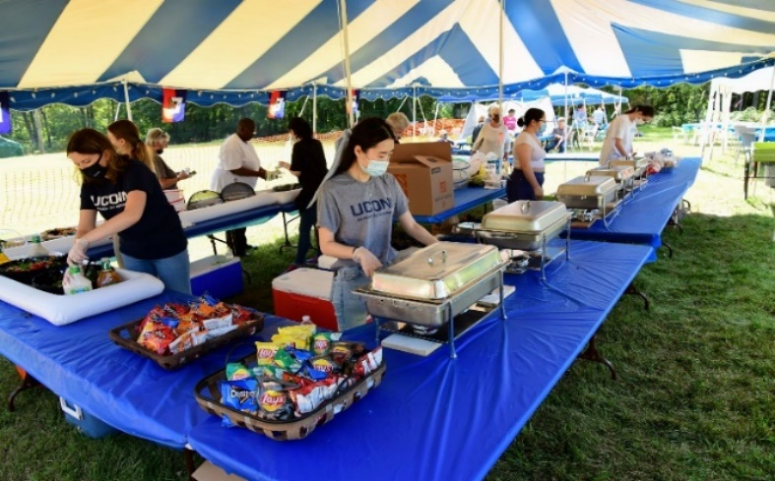
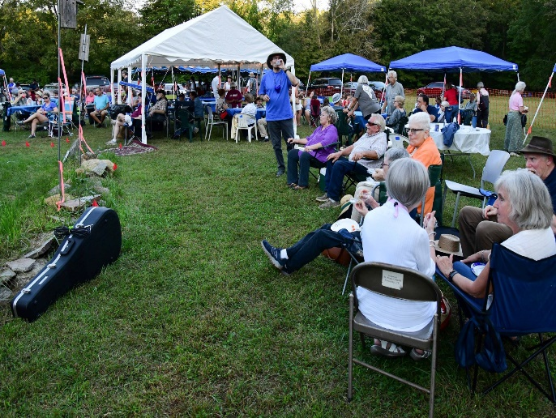
Haiti was tested with natural disasters - a hurricane, followed by an earthquake - and political turmoil including assassination of their President. Our school endured despite intermittent closings. Sixth grade students completed their standard, end-of-the-year tests on July 23-26.
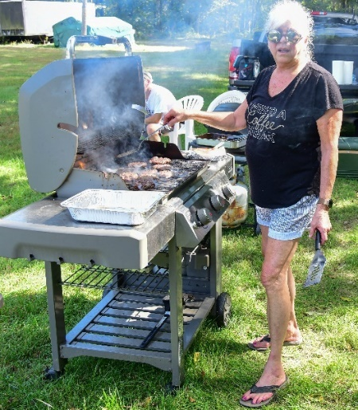
Our 6th Annual Pig Roast & Concert, held on September 18, had beautiful outdoor weather. Our event attracted 86 newcomers and many of our loyal supporters. Peter Fish provided the great pictures.
Curt Brand and the On Call Band, Seldom Heard, Quiet Corner Fiddlers, Kev and Company, and Karen Bushey Lussier provided 6 hours of Connecticut’s finest live music. Guests enjoyed lots of great food! Chef Amy Moore organized and coordinated our food tent, as well as grilled the additional chicken and burgers.
UCONN Professor Marie Smith recruited 16 students from the School of Pharmacy to manage the food tent. Gloved and masked, they served guests for six hours, a substantial contribution the success of the event.
Friends of Ecole Agape had a booth at Celebrate Mansfield in September. Jeannette Picard, Judy Melichar and Jane Moynihan presented a variety of activities to highlight the school and its students. Treats and snacks were available to the community. Photo opportunities were presented in front of a pair of Ecole Agape wings.
October through December
Our membership worked on the Sponsorship Appeal from October through November. We appreciated the support of one hundred fourteen generous contributors who purchased a variety of sponsorship that netted $35,000 for Ecole Agape.
Jeannette Picard and Jane Moynihan emailed letters to teachers expressing encouragement and appreciation to the students for their determination and perseverance in their studies under very difficult circumstances.
Rikke Wassenberg forwarded free online worksheets for the teachers from Haitian Advanced Learning Opportunities (HALO) for classroom use. The school is looking at HALO as a Haitian-based resource.
Seven barrels packed with 20 sewing machines, sewing supplies, and fabrics were sent to Ecole Agape. In addition, rain ponchos, school supplies, 150 T-shirts donated by South Windsor Haiti Group, three guitars, and French books donated by Marianne Labergerie were included. With the increasing cost of shipping, the membership is comparing purchasing supplies in Haiti vs. the United States.
At our November meeting, we elected officers for the next calendar year.
At our December meeting, the membership voted to form a finance committee. Larry Grasso, Michael Bartron, and Anne Rash agreed to serve and were unanimously approved. The Finance Committee will be responsible for finding and working with a brokerage firm with experience working with non-profits and overseeing investments. The by-laws have been revised to reflect this new activity.
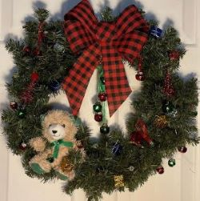
1ST PLACE “COUNTRY SANTA” BY TINA PELLITIER 1ST PLACE “GIFTING” BY JOSIAH EDWARDS
December concluded with the 2nd Annual Wreath Decorating Contest and Silent Auction. In the Adult Division: 1st Place, Tina Pelletier with “Country Santa”; 2nd Place, Michele Calabrese with “Blush Beauty”; and 3rd Place, Rikke Wassenberg with “Wreath in Stone.” In the Children’s Division: 1st Place, Josiah Edwards with “Gifting”; 2nd Place, Kimber Audette with “Candy Cane Wreath”; and 3rd Place, Stella De Crosta with “A Very Beary Christmas.”
Winners presented their $700.00 of cash prizes to Feed Our Vets, Journey Home, and Craig’s Kitchen.
The Wreaths were displayed on December 4 at Mansfield’s Winter Welcome in Storrs Center. The Willimantic Chronicle featured our Haiti Awareness booth, manned by Judy McChesney and Rikke Wassenberg, who were supported by Bob Jennette, Bruce Vissoe, and Dennis Foran.
Our 6th Annual Cannister Campaign continued, but in a very limited capacity because of COVID.

We thank you for your generosity in 2021; invite you to our 2022 events; ask you to consider a sponsorship; and consider sharing your time and talents by becoming a member of Friends of Ecole Agape. We ask you to consider designating Friends of Ecole Agape, Inc as your charity on Amazon Smile.
Please know you have made a difference in the life and future of a child.

Friends of Ecole Agape, Inc. Chairs: Susan Hacking and Michael Bartron; Secretaries: Judy McChesney and Lillie Tierney; Treasurer: Larry Grasso: Social Media and Technology: Sheila Appleton and Rikke Wassenberg. Members: Cindy Moeckel, Ted Hill, Judy Belek, Mary Anne Brennan, Anne Rash, Catherine Belanger, Jeannette Picard, Peter Kirk, Jane Moynihan, Judy Melichar, Leigh Gwara, Amy Moore, Mary Ertel, Marie Ann Smith, Mary Romney, Lorraine Cloutier, Rabbi Jeff and Mindy Glickman, Saud and Yusra Anwar, Dianne Aborn.
Members Emeritus: Lucy Hill, Kacee Erhard, Diane Giggey, Maggie Kirk, Barbara Pivarnik, Mary Wehrle, Mary Patrone, Dick Long, Dr. Tom Gorin, Paul and Elizabeth Wicks.
Please visit us on the internet at: www.friendsofecoleagape.org;
on Facebook https://www.facebook.com/friendsofecoleagape
on Instagram https://www.instagram.com/friendsofecoleagape/
or write to us at: friendsofecoleagape@gmail.com.
Statement of Receipts and Disbursements
For the Years Ended December 31, 2020 & 2021
Receipts | 2020 | 2021
Total receipts | $ 62,803 | $ 64,467
Less: Fund raising expenses | 1,028 | 2,366
Net Receipts | $ 61,775 | $ 62,601
Interest Income | $ 608 | $ 6
Program expenses
Teacher & librarian salaries | $ 11,942 | $ 10,248
Secondary school tuition | 850 | 1,000
School supplies & books | 1,820 | 1,650
Nutrition program salaries | 2,054 | 1,956
Food | 14,922 | 18,000
Internet Access | - | 240
Solar lights | 1,485 | 225
Sewing Machines | 150 | 1,650
Backpacks & Ponchos | 173 | -
Shipping | 420 | 1,140
Wire transfer fees | 320 | 390
Perimeter wall enhancement | 2,825 | -
Total program expenses | $ 36,961 | $ 36,499
Other expenses
Postage & office supplies | $ 617 | $ 709
Insurance, legal & filing fees | 290 | 150
Total other expenses | $ 907 | $ 859
Net Surplus | $ 24,515 | $ 24,749
Statement of Financial Position
December 31, 2020 and 2021
Assets | 12/31/20 | 12/31/21
Cash in bank | $ 84,422 | $ 108,384
Undeposited cash on hand | 4,800 | 4,810
Accounts receivable | 600 | 3,495
Angel t-shirts, bags & blankets | 1,332 | 1,164
Haitian crafts | 500 | 500
Solar lights | 600 | 300
Sewing machines & supplies | 1,650 | -
Total assets | $ 93,904 | $ 118,653
Liabilities & Fund Balances
Restricted fund balances | $ 1,965 | $ 2,170
General fund balance | 91,939 | 116,483
Total liabilities & fund balances | $ 93,904 | $ 118,653

